Hello, everyone, I’m the person who develops database.

My job: change the types of data, create the rules of database.

excel (\*.xls and \*.xlsx) 🡪 data in the database.

1. the change of data

We consider changing the \*.xls into data into database. Python 3.9 allows us to do the work: This code allows us to read every line of excel.

Technologies sharing:

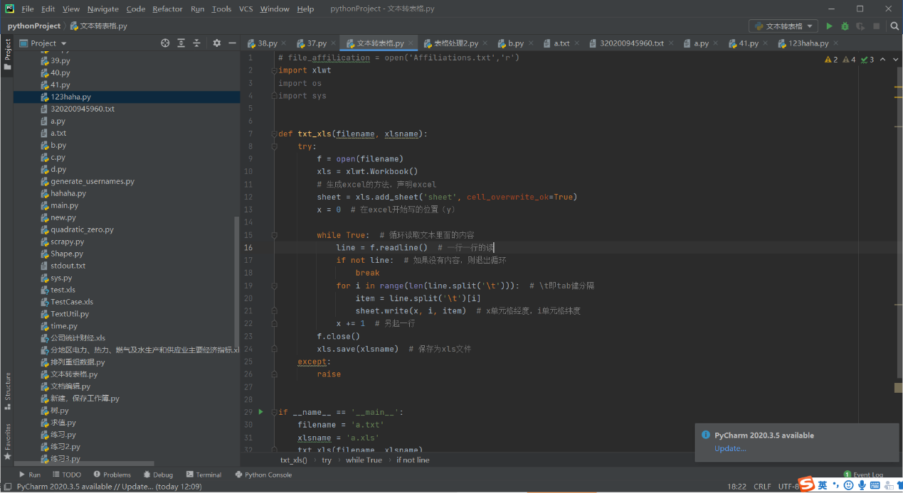

We can see the result of database:

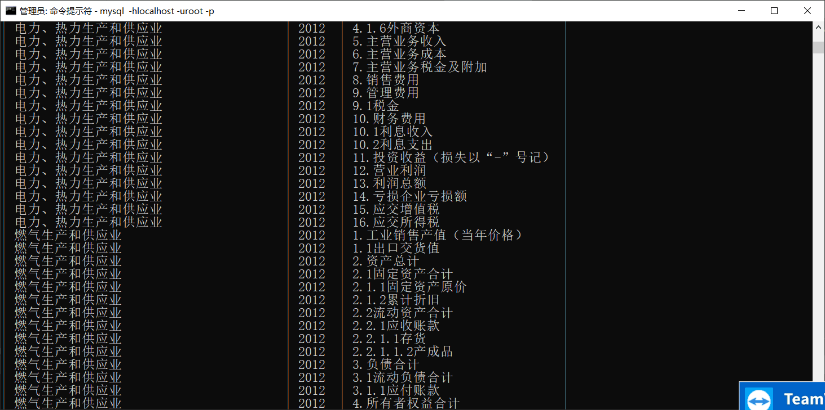

1. the process of data

Since our files are all in the form of excel, we consider processing the data of excel to change it into the data we need then put them into database.

The standard we need: 3 tables of financial anaylsis

1.Income statement

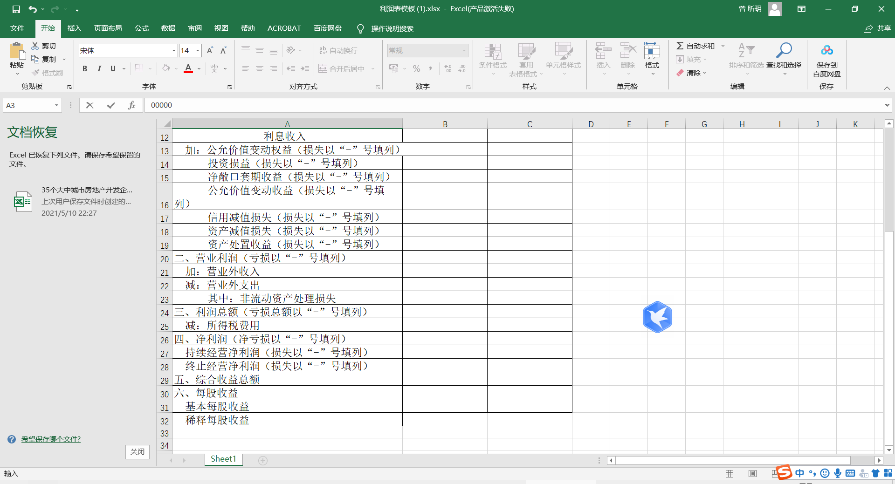

2. Balance sheet

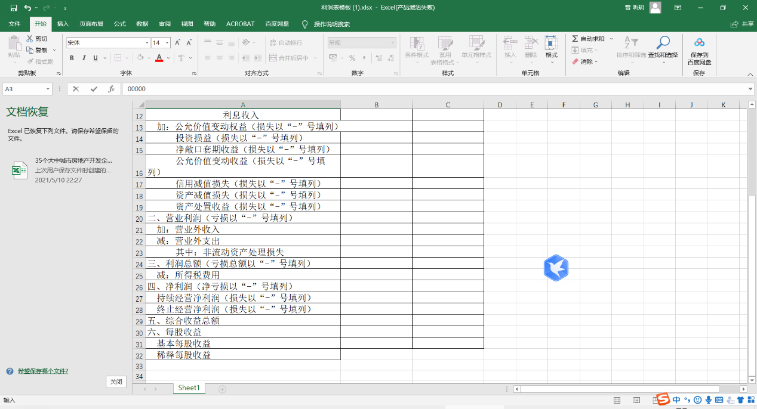

3.Cash flow statement

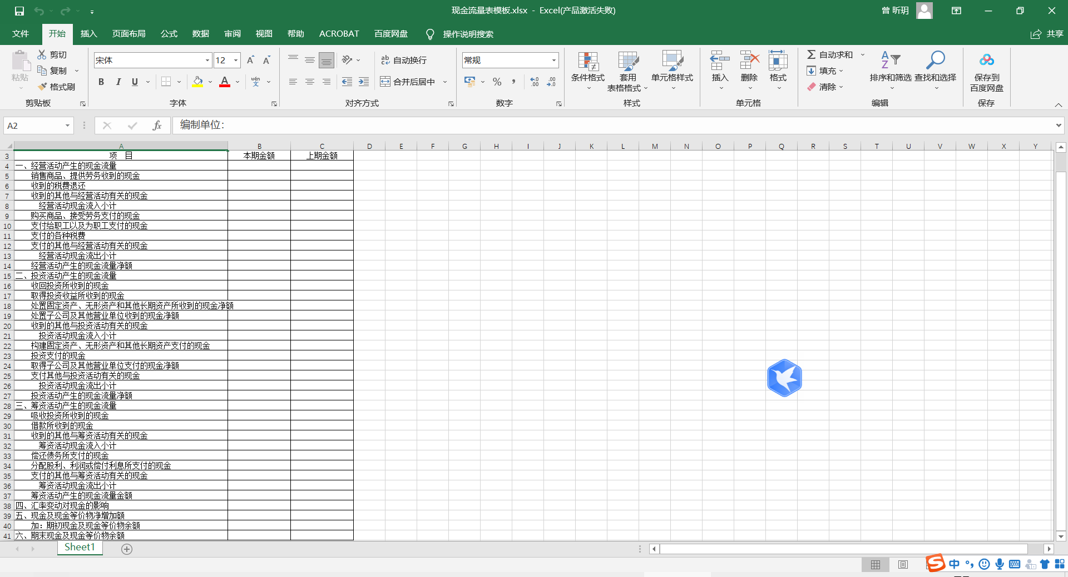

3. Database creation

1. Data schema

The graph below shoes how join table develops.

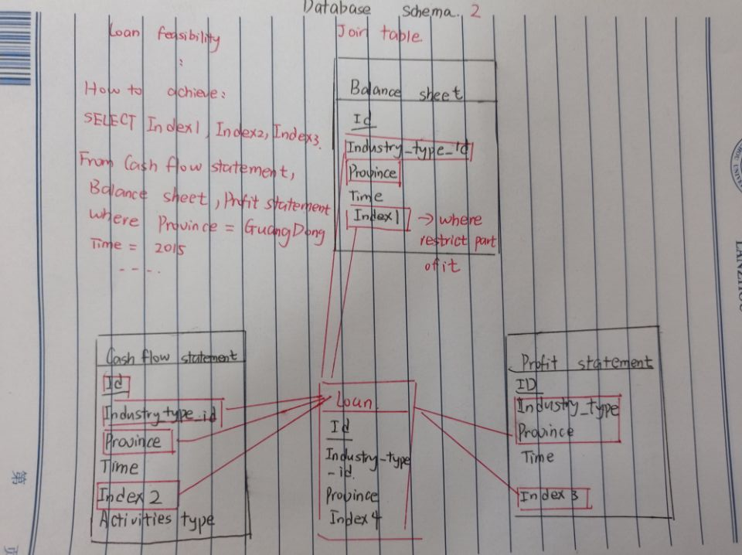

2.Data relationship (ER)

